Viewpointer

Introduction :
An essential element of any GUI interface is the mouse. Specially so, the look of the mouse pointer plays a vital role in determining the overall appearance of any application. Although DOS provides various methods to create mouse pointers and change their appearance, the method is often cumbersome to follow. Viewpointer is a utility to design fancy mouse cursors for DOS applications. The interface of this utility has been developed using the accompanying “VISIONIZZER” interface designer.
A self explanatory tutorial has been enclosed in a floppy.

Mouse in DOS:
It is a known fact that the interrupt is reserved for various functions of the mouse. As far as the text mode is concerned, the beauty of the mouse pointer is limited to the number and the display of the scan lines. However, on switching to the graphics mode, enormous potential exists in deterring the look of the mouse cursor. The interrupt 33h, is usually the documented mouse handling set of routines in DOS. The MS-DOS manual also suggests the service 9 to be used for creating user-defined graphical mouse pointers. This service is for changing the mouse pointer to a user defined bitmap. The DOS manual defines two bitmaps namely, a cursor mask, whose contents are ANDed with the screen contents and a screen mask whose contents are XORed with the present screen pixels. It also defines a pixel on the bitmap, called the hot spot, which determines the actual position of the click of the mouse cursor. Declaring the bitmaps as 32-byte areas in the screen, each holding the required bitmap may be quite cumbersome, as it requires the creation of a raw diagram, changing its bits to sequential byte values and then passing these parameters to the interrupt routine. Further, there is also a need for producing a standard mouse library that defines various mouse cursors to avoid clustering the actual program with the chunks of 64-bit data values. This utility, presented here, is an attempt to automate the entire process. It was written using the accompanying “VISIONIZZER”, to demonstrate the ease of an interface generation with the software and its ability to increase the GUI savvy production of DOS or other character based interface applications.

The Interface:
The opening screen is equipped with two sets of grids and a number of buttons. The left grid is the cursor mask that determines the actual look of the mouse pointer. The right grid is the screen mask. The cursor mask area is Boolean ANDed with the current screen contents, while the screen mask bits are XORed with them, as mentioned above.
The cursor can be designed in the cursor mask area and a left click fills a cell of the grid. To clear the cell, right click on the cell. Below both the grids, appear a set of buttons with arrows on them, that may be used for reflecting on half of the cursor to the other. The six buttons that follow also help the user in designing the cursor and screen mask areas.
The copy button on the right of the screen is used to enable easy copying of cursor mask to the screen mask. The not button complements (Boolean NOT) the contents of cursor mask to the screen mask.
The button “Test” converts the current mouse pointer to a format that the one designed by the user. Click on reset again to revert back to the original mouse pointer.

Built-in Library :
This utility also provides a library to store the created cursors. The “Prev” and “Next” buttons can be used to switch through the various cursors in the library files. The cursors can then be loaded from the library file. This results in the saving the program space. The cursors in the library have a default hot spot at the center position. The hot spot position can be changed using the HotSpot mode. The hot spot is then clicked in the cursor mask grid. To recover to the ordinary drawing mode, the draw button must be clicked. Cursors may be saved or added to the library file using the “Save to Library” button. The default cursor file is cursor.c and contains the cursors in the format :
char name[64] = { ..........}
These names can be passed as direct arguments to the interrupt routines, or can be used in conjugation with the header file enclosed - mouse.h
For quick inclusion of the code that can change the mouse cursors, select the “Output to file” option and type in the name of the file. The required code is appended at the end of the file.
Conclusion :
This interface was generated by the “VISIONIZZER”, as earlier mentioned. All the mouse cursors available in “VISIONIZZER” were developed using this utility. Thus, we have included this utility with the VISIONIZZER, as an add-on to aid the easy development of mouse enabled interfaces.
TIC - TAC - TOE

Introduction:
This is the classic tic-tac-toe game, also called knots and crosses. The interface of this game was generated using the accompanying software, VISIONIZZER. The mouse pointer was developed using the above mentioned Viewpointer. This is a simple game, but requires a high degree of structured analysis to actually take full control to win the game. This accompanies the above mentioned software, ‘VISIONIZZER’, to illustrate the fact that the software removes the hassles of designing interfaces and lets the user concentrate on the finer aspects of programming. The challenge of this game is to win it, against the computer. This is a single player game and the player plays it against the computer. The game may end in tie, but as far as theory of the game is concerned, the chances of the player winning have been reduced to a bare minimum.

The Game rules:
The game area is as follows
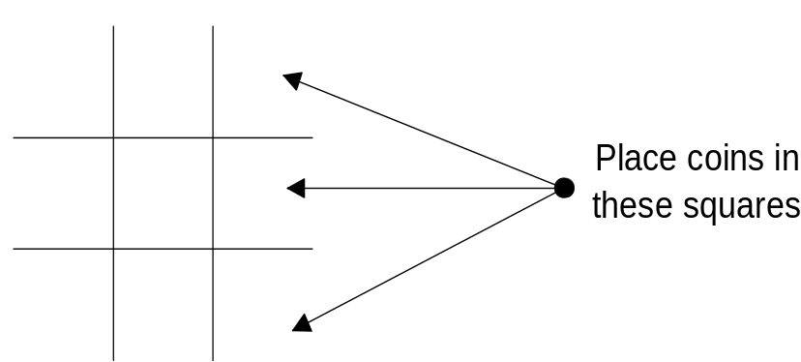
The player plays in one of the 9 squares. This is followed by the computer playing again. Once a coin is placed, you cannot move it. The objective of the game is to get your coins in a straight line. Getting the coins along the diagonal lines is also permitted. The one who gets the coins in a line first is the winner of the game. The player plays with a circle (knot) and the computer uses a cross. A sample game as the coins are placed is as shown below. The picture below shows the sequential play of the game, where each turn is showed by a board position.

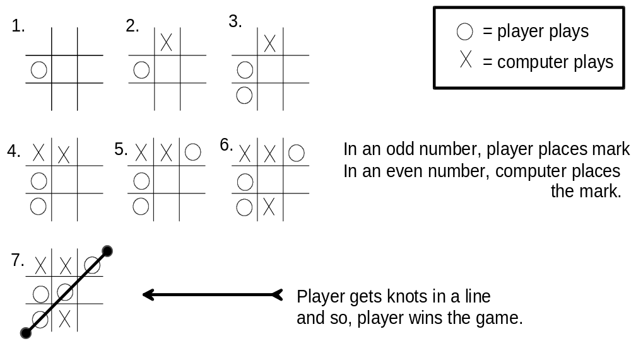
Theory of the Game :
Normally, this game uses Artificial Intelligence to play and win. However, a different logic has been adapted to exploit some inherent pointers this game offers, to increase the chances of wining if played first. This program first calculates all the possible ways of placing the coins and then selects the best out of them. By this, the possibilities of finding hidden situations, where the player is forced to play at particular positions has been resolved. In short, the computer analyses all the ₈P₈ possibilities to find out the best. Thus, this logic may be regarded as a rough cross between the dynamic best solution finding Genetic Algorithms and the heuristics search.

Conclusion :
The game requires a great deal of planing and tricking the computer into playing the game into a wrong position. The enclosed floppy contains three executables -
1. Knots.exe - Overall game console that calls the following executables
2. Knots1.exe - Game when the user plays first
3. Knots2.exe - Game when the computer plays first
When the player plays first, the probability that the game is drawn is significantly high. Similarly, when the computer plays, the probability of the player loosing is relatively high. This game is included with VISIONIZZER to demonstrate its ability to support higher-end logic processes.
Parallel Port Tester

Introduction :
In the modern day world, the existence of any stand-alone computers without the external agencies is difficult. The most common interfacing of the computers are done using the serial and the parallel ports. The newest inclusion in this series is the high speed Universal Serial Buses. Each has its own advantages and disadvantages.
This utility presents a base that may be used to test the various outgoing and incoming transmissions of the parallel ports. The utility may be used to send bytes of data to the port and receive chunks for it. It also gives a choice of using the LPT1 ad LPT2. This can be used to test any communications through the parallel ports to a hardware, as the GUI provides and easy interface to write data to the pins and read data from the pins.
The interface of this utility was generated using the accompanying “VISIONIZZER”. Thus, the interface provides a direct graphical display of the pin-wise input and output systems.

The Parallel Port :
The parallel port considered here is the ordinary, non-bidirectional, parallel port. The extended parallel port is not used because it might not be supported on the older systems. Nevertheless, this system may be well extended to the extended parallel port also. The documentation specifies that the parallel port has 25 pins. These pins have four type of connections. Of these, the pins 2-9 are used as output pins and are write only pins. These are of the TTL type and are powered by the 74LS374 chip. Four controls pins that are read/write capable and have open collector outputs is used. The Pin numbers of these control bits are as follows. These are available at the offset of base+2. These exact bit locations are available in the tester. The base signifies the base address of the parallel port (378h for LPT1, 278 for LPT2)
1 | Strobe bit, for pacing data
14 | Auto form feed pin (printer)
16 | Initialise printer pin
17 | Select input pin

The five status pins are read only. The inputs are read by a 74LS240 chip and use the TTL logic levels. These are read from an address of Base+1.
15 | Error Pin
13 | Select printer
12 | Out of paper pin
10 | Acknowledge
11 | busy

The rest of the pins, 18-25 are signal ground pins. These pins are to be used as ground component in the transmit pins twisted pair cables to cancel the noise.
The Interface:
The interface is quite a simple on to work on. The two main areas are the transmitter and the receiver parts, where the pins, their logical addresses and data are displayed. The data can be set or reset in the transmitter area by clicking on the bits. The data may also be changed using the decimal value, while the corresponding data that may occur on the pins is displayed. The send data is to be clicked to have the voltage variations on the output.
Similarly, in the receiver side, the Poll Port button shows the current data that might be available to the port. The set read mask is to set the mask - 04h to the port, to read data from the control port. The graph below it is to read and display any distinct values that may occur at the port. This is done to avoid missing distinct values that may be lost due to the speed of the polling. To stop polling the port, the stop button may be used. The port can log data either at the port+1 base addresses or the port+2 base addresses.
Finally, the exit button quits the utility.

Conclusion:
Although this utility was not specifically designed to achieve great speeds or the perfection of the professional parallel port interfaces, the design may be well improved to obtain the required efficiency. This was developed to test the parallel port, but the source code may be modified to obtain a better interface.
As mentioned earlier, this software was generated using the accompanying VISIONIZZER, to demonstrate its prowess in the applications that require speed coupled with easy interfacing capabilities. The application of VISIONIZZER in the area of interaction with the hardware is demonstrated.

